Sri Vinay Appari

CMPE 256: Assignment 05

**Open CV and Deep Learning**

Please note that you can also view the google Collab notebook at my GitHub Repository link:

<https://github.com/SriVinayA/SJSU-CMPE256-AdvDataMining/tree/main/Assignment%205/OpenCVAndDeepLearning>

Please see below for the output that was generated by running my Google Collab notebook on the pictures that the professor provided to us.

Open CV Pictures:

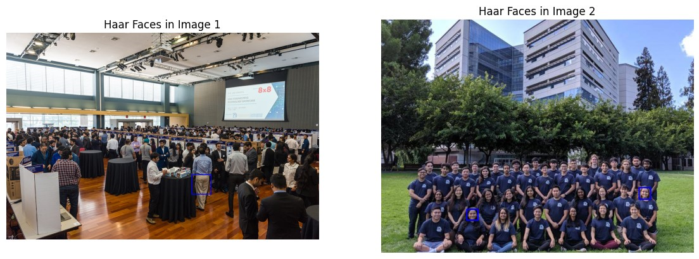

Deep Learning Pictures:

